DREMA 2022 – MTP GOLD MEDAL

Innovation, creativity and modernity - this is how you can summarize the products that won the Gold Medal of DREMA 2022 this year. The Competition Jury decided to award 13 prizes.

In the competition for the Gold Medal of the MTP Group, the award is given to products that meet the statutory criteria and receive positive recommendations from a professional jury consisting of outstanding specialists in the field of wood processing technology and furniture production. The members of the Competition Jury are looking for modern, innovative products manufactured with the use of top-class technologies, characterized by special qualities.

The winners are now fighting for a vote in the Gold Medal Consumers' Choice competition. Voting lasts until September 8, 2022.

Laureates of The Gold Medal on DREMA

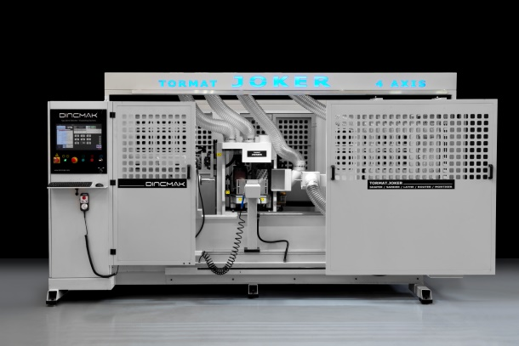
4-Axis Machining Center CNC TORMAT.JOKER ATC

TORMAT.JOKER ATC 4-AXIS CNC MACHINING CENTER is a multifunctional machine designed for wood machining, turning, grinding and 4-axis detailed milling. It is a 4-axis CNC machining center and a wood lathe at the same time, which is designed for manufacturing sofas, chairs, tables and furniture legs etc. It enables the user to easily shape, carve, drill openings, engrave and perform finishing works. The machine has 6 various processing units: milling head, turning knife, electrospindle, grinder, and optionally a detail grinder and a cutting saw. It is unrivalled thanks to its robust and innovative body design, high-quality materials and excellent optional features. It guarantees fast manufacturing process and high quality. It is safe to say that TORMAT.JOKER is the market leader for high-quality materials and affordable prices!
DINCMAK Machine - applicant and producer

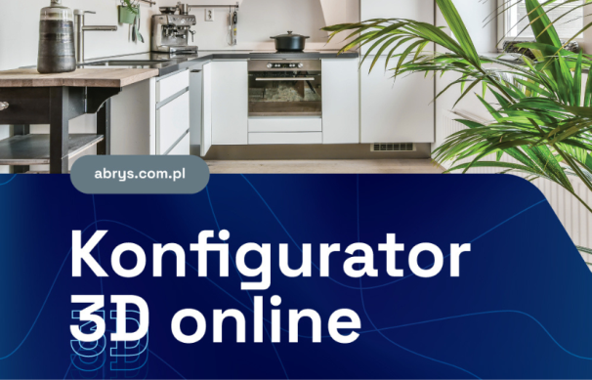
ABRYS SYSTEM B2B online
Complete solution for wholesalers

ABRYS SysTEM B2B is the most modern solution on the market. ABRYS is the only fully INTEGRAL and 100% online solution available on the market, which handles the entire process from furniture configuration to its manufacturing. This means that all system functions operate within one consistent online program, based on one consistent database. Online configurator and order processing for production are integral elements of one system. There is no need to send the project to a separate processing program. ABRYS allows user to simplify and speed up the execution of orders, reduce the costs of errors and minimize waste of board cutting process. It provides comprehensive support for carpenters, relieving them of time-consuming work, facilitating the process of preparing furniture for consumers. The system ensures transparency and control over the entire order execution process.
ABRYS Maciej C. Rezner - submitting entity and producer Spiral cutter

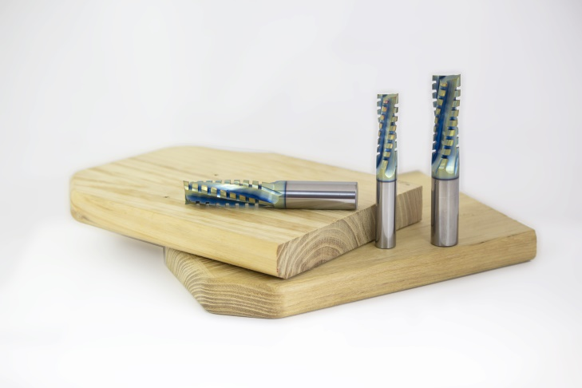
Spiral milling cutter VHM V406.XB

New discovery. Is there anything new to discover in woodworking cutters? With its new V406.XB cutter, N-POL company proves that there is. Everybody knows the 3 basic spiral cutters for woodworking, which have been copied and produced by all manufacturers for years. Finishing cutters, roughing cutters or roughing-smoothing cutters. Clockwise and counterclockwise cutters often have to be used to obtain a good surface in solid wood without breaking the fibres. It causes the disadvantage of changing tools and extending the machining time, whereas the effect is far from the intended one. One V406.XB cutter changes that and breaks the entire routine.
N-POL Krzysztof Noga - applicant, N-POL Cutting Tools – producer

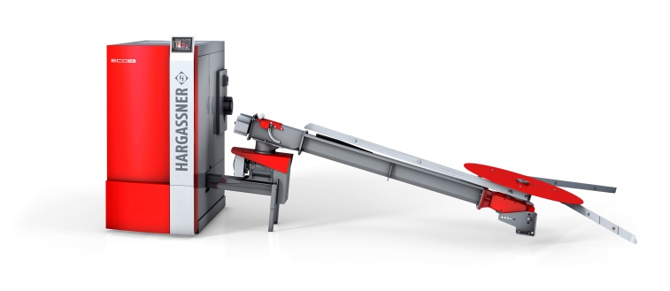
Hargassner ECO-HK 30 kW Wood Chip Boiler

Hargassner ECO-HK wood chip boilers use the cheapest available fuel and provide energy-efficient and CO2-neutral heating. With efficiency up to 95%, energy label A+ and available power from 20 to 2000 kW, they offer comprehensive solutions to all customers. State-of-the-art technical solutions such as: crushing rotating grate, exhaust gas recirculation and energy-saving 300 W igniter ensure minimum power consumption. It is possible to connect them to a wide range of home automation systems.
RAKOCZY STAL sp. Z o.o. - applicant, HARGASSNER Ges mbH – producer

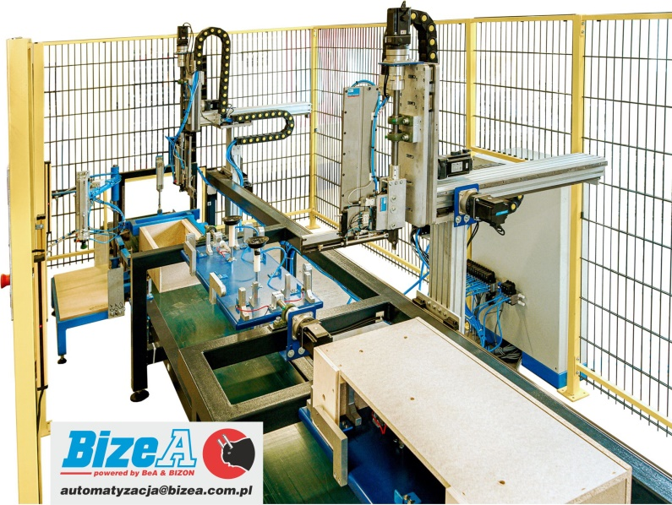
CNC line for the assembly of armrests (elements of upholstered furniture frames)

CNC line for the assembly of armrests, which replaces at least two assembly stations. It is designed for producing a complete element on one station operated by one operator. The target plan assumes one operator on two twin lines. Benefits: increased efficiency, lower employee experience necessary, increased work safety, guaranteed repeatability and product quality.
BizeA Sp. Z o.o. - declarant and producer

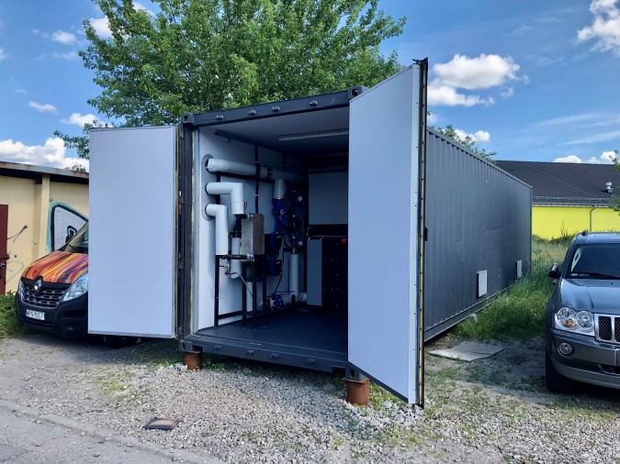
Mobile combustion system for wood-based and biomass waste
This mobile waste combustion system with a power of up to 960 kW enables every company to manage ecological combustion of own waste. The process of waste combustion provides free thermal energy and when a turbine is used, also electricity. Mobile waste incinerators may be dedicated to the combustion of wood-based waste, alternative and composite fuels. With the technology of safe waste incineration, the users can transform waste into cheap heat and electricity with virtually no emissions. We used the technology of after-burning gases at high temperatures in a special ceramic chamber. The mobility of the solution with its container design, enables quick delivery of a ready-to-work device. Importantly, the device can also be rented for a specific period of time to dispose of waste.
FCC innowacje sp z o.o - applicant and producer

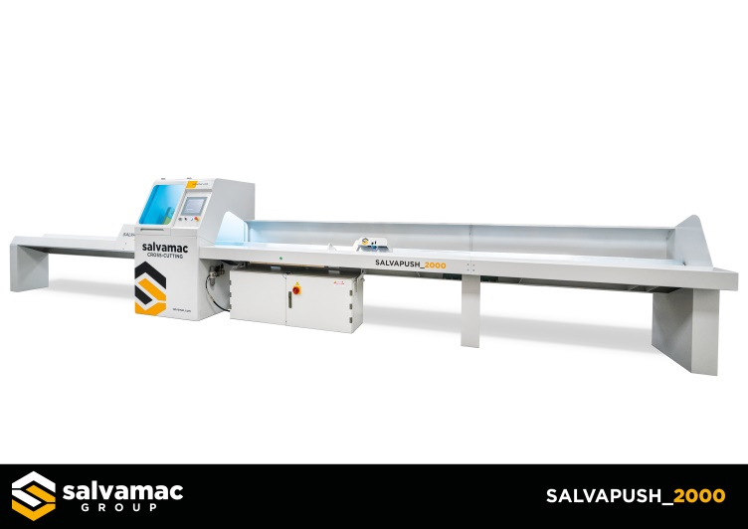
Salvapush 2000 optimizing saw Optimizing the cut for individual customer needs is part of our DNA and this is just the beginning. We have created a very flexible and avant-garde technical solution that allows users to optimize individual boards at a reasonable price in individual quality classes or packages of boards using the most advanced technology. Salvapush 2000 is equipped with a completely new version of the software that allows the operator to control it in a simple and complete way, just like a smartphone.
SALVAMAC sp. Z o.o. - declarant and producer

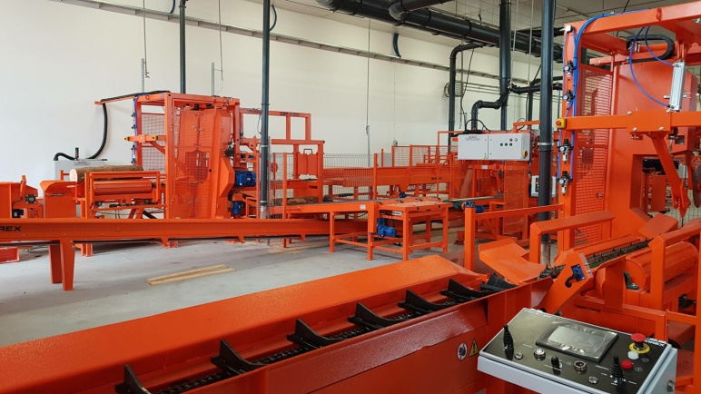
Vertical Twin Band Sawmill
of CZP-2/ZM type
CZP-2/ZM Twin Band Sawmill is the heart of our complete log sawing lines with a capacity of up to 100 m3 of round raw material per shift, which are used both in the country and around the world. It is a product that received the Innovation Opinion issued by the Wood Technology Institute in Poznań, and which was the basis for the implementation of the project entitled Introducing Innovative Wood Processing Lines to the Market, financed by the national government and European funding.
W-IREX Przedsiębiorstwo Prywatne Wiesław Ciura - applicant and producer
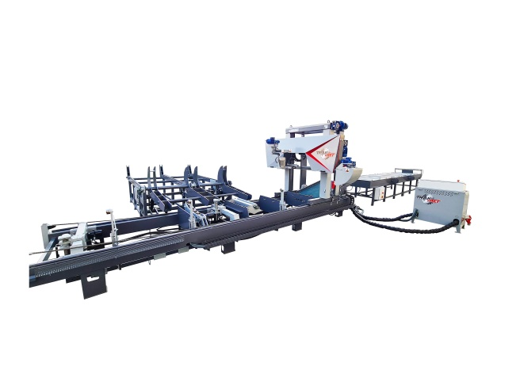
TTS-1200 Industrial Band Frame Sawing Machine
TTS-1200 Industrial Band Frame Sawing Machine is designed for processing hard, exotic logs with large dimensions, up to 1350mm in diameter. The sawmill is intended for continuous three-shift operation in harsh climatic conditions.
PPHU TRAK-MET Zbigniew Skillandat - applicant and producer

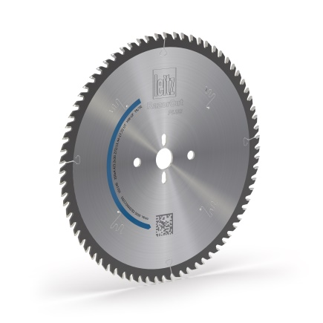
RazorCut – PLUS circular sawblades for cutting wood-based panels individually and bundled up, with ultra HW blades.
RazorCut – PLUS main sawblades for cutting wood-based panels, individually and bundled up to 60 mm of height, with ultra HW blades. Special blade geometry helps to obtain the quality and dimensions of finishing cut. The tool offers operational lifetime several times higher than conventional saws. Excellent design with new laser ornaments and special filling ensure vibration damping during operation and reduced of noise level. Reduced cutting forces decrease power consumption.
LEITZ POLSKA Sp. z o.o. - applicant, Leitz GmbH & Co. KG – producer

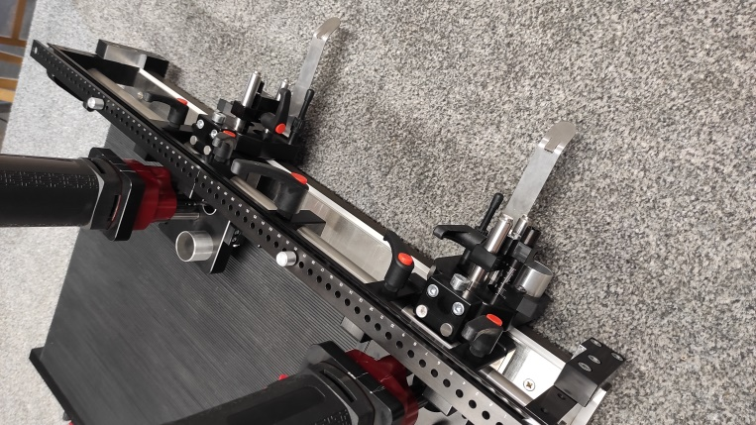
RC SYSTEM table - a station for precise drilling furniture templates and a method of drilling a furniture template
The RC SYSTEM table enables quick, safe and repeatable drilling of various furniture templates, regardless of the conditions of use. It is small, solidly constructed with the use of high-quality materials, easy and cheap to operate. It is a complete solution, a technology in itself. The product reduces the time needed to perform the work and the costs of its execution. The table increases the competitiveness of small and medium-sized workshops producing customized furniture.
ROTOR-CENTRUM s.c. Bogdan Ostachowicz, Agata Ostachowicz, Małgorzata Kubicka - submitting entity and producer

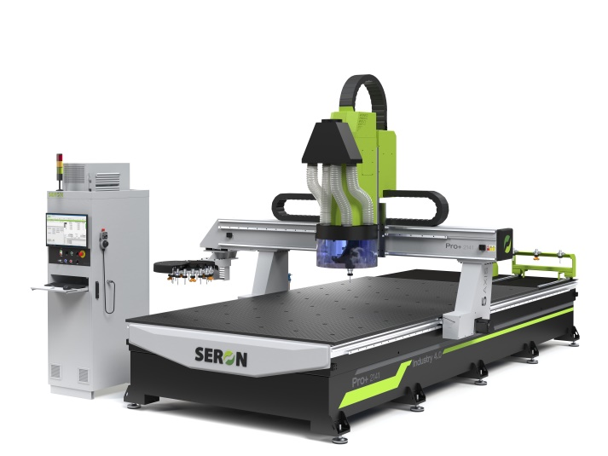
Automated machining center
5AXIS PRO+ 4.0
5AXIS PRO+ 4.0 automated machining center is a new product in the SERON offer. It was designed to answer the needs of the carpentry industry. The configuration of the machine center enables its integration with an extensive machine park managed in the Industry 4.0 concept. It is also an excellent equipment for extending a carpentry workshop. The center may be integrated with a robot for a comprehensive optimization of production costs due to reduction of required manpower and minimized production errors.
SERON Limited Liability Company Sp. K. - declarant and producer

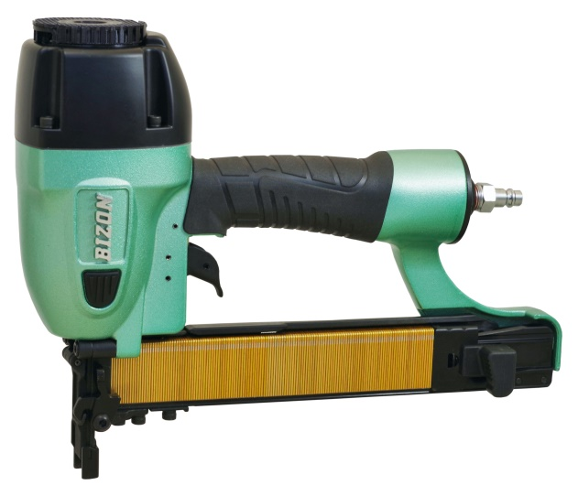
BIZON pneumatic carpentry staplers for construction staples of 14 BIZON 14/40-B74 and 14/50-B81 types.
Industrial pneumatic staplers for 14/40 and 14/50 BIZON carpentry staples. The perfect balance between driving force and weight makes them extremely innovative and effective tools. 14/40-B74 is dedicated to the production of upholstered furniture frames, while 14/50-B81 to all structural joints. Thanks to the unprecedented reliability and precision of operation, it is especially highly recommended for furniture factories and all plants producing wooden structures, where the costs of operating and servicing tools are of great importance. Various equipment options: the option of an extended cartridge and adaptation to work on the machine, mounting for a balancer that facilitates work, option for a protector securing the punching of hooks for springs
BizeA Sp. Z o.o. - declarant and producer

